Name_________________________________________________ Period_______
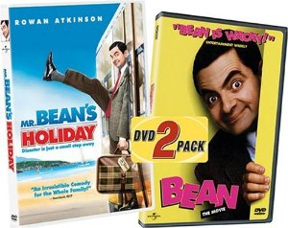
Contemporary British Literature Mr. Bean
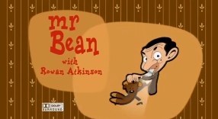
Mr. Bean played by Rowan Atkinson, first aired on British TV in 1990. During its five-year run, the series gained large UK audience figures, including 18.74 million for the 1991 episode "The Trouble with Mr. Bean". The series has received a number of international awards, including the Rose d'Or. The show has been sold in 245 territories worldwide and has inspired an animated cartoon spin-off, two feature films, and an appearance at the London 2012 Summer Olympics opening ceremony.
For this assignment, you will watch one of the TV episodes, A Christmas Special. You will answer Part 1 and Part 2 questions at the same time as you watch the show.
Part 1-
Answer the following questions:
1. Mr. Bean gets in trouble at the department store. Why?
2. When we are introduced to what appears to be his girlfriend, what does she hint to Bean to get her for Christmas?
3. Bean helps a band that is raising money for charity. How does fill up the collection bucket so quickly and how does this relate to Oliver Twist?
4. How is he rewarded for collecting so much money?
5. Who sends Mr. Bean Christmas Cards?
6. Bean retrieves a box of Christmas Crackers from the closet. Research online what they are. Write a paragraph description of British Christmas Crackers to someone that has never heard of them (separate paper).
7. Describe how he celebrates Christmas Eve in his home:

8. What does he wear on his head Christmas morning?
9. What does he get his girlfriend for Christmas? (2 presents)
10. Why is there an explosion at the end of the show?
Part 2-
If you knew nothing about England, list 10 things about England or Christmas that you identified while watching this show:
1

2

3

4

5

6

7

8

9

10

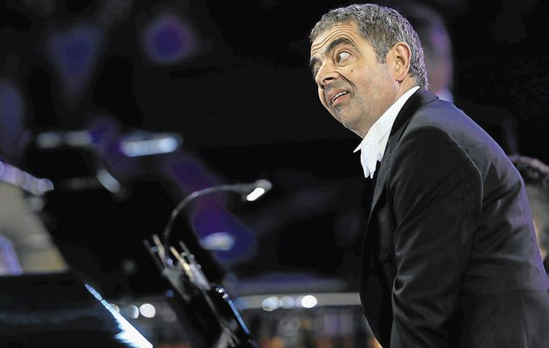
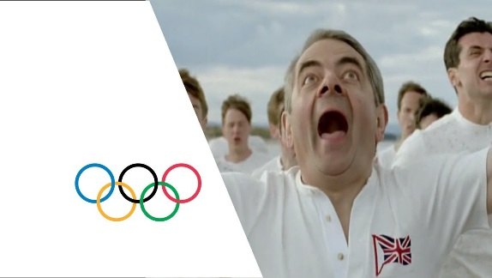
At the opening ceremony of the 2012 Olympics

