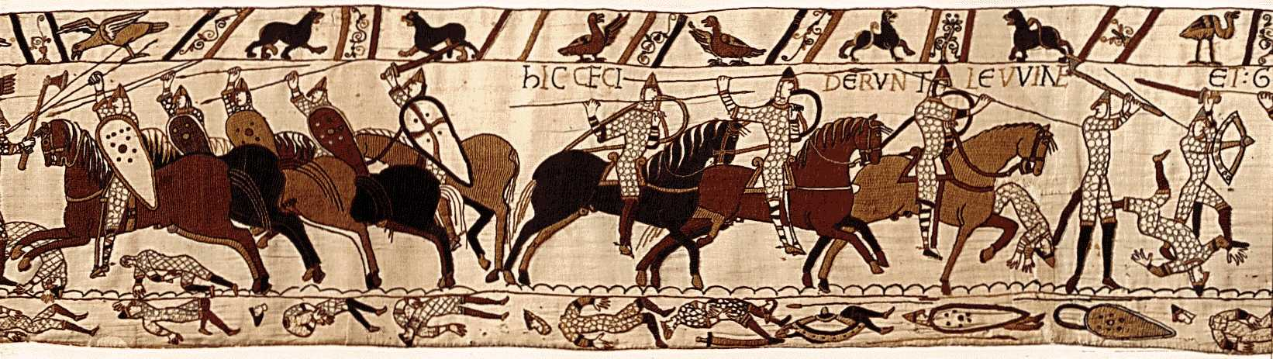
The Anglo- Saxons Name_______________________________
449-1066 A.D. Period________________________

Name 6 different groups of people that invaded and settled Great Britain:
1. 2. 3.
4. 5. 6.
7. Where does the name Britain come from?

8. Who is believed to have built Stonehenge?
9. Where was it built?
10. Why was it built?

How do the Celtic stories differ from the Anglo-Saxon tales? (list 6 examples)
11. 12. 13.
14. 15. 16.

17. When did the Romans invade Britain?
18. When did they leave?
What did they build and leave behind? (list 4)
19. 20. 21.
22. And what religion did they bring? (list 1) 23.

24. When did the Anglo- Saxons invade Britain? (Hint date above)
25. Where did that Anglo- Saxons come from?
26. Where did the Jutes come from?
27. What name did they give Britain?________________________ or today known as?__________________

28. It wasn’t for another almost 450 years that England finally became unified and a nation.
Who was responsible for this?
29. Religion also played an important role in unifying England. What religion?
30. Why did the people convert?
31. What event in 1066 brought an end to this period? (Explain in a few sentences)

32. During this time. How did an individual gain fame and success?
33. What rights did women have during The Anglo- Saxons? (Give examples)

34. The word Wednesday was named after who?
35. What was he?
36. What is the protector of treasure?
37. What mythology or religion does he come from?

38. What is a bard?
39. What did Anglo- Saxons call them?
40. What was the bard’s status in this society?

41. Where did scholars learn?
42. How did texts get written?
43. In the winter what would freeze?
44. What was the paper made of?
45. What was it called?
46. What language did King Alfred make respectable? (two words) _____________ ____________________

Connection To You
We live here in America, why do we care about England 1500 years ago?
Maybe look at it this way. Does America’s culture and life today resemble the Native Americans that have been here for thousands of year –no. The British and other Europeans that came to America shaped America’s culture and way of life that is familiar to so many today.
Write a half a page about how your life or life in general in America was influenced by this literary period:

